**

**MULTIPLE timesheet To be completed and returned by 16:00 on the following SUNDAY to be processed for payment.**

|  |  |  |  |  |  |
| --- | --- | --- | --- | --- | --- |
| **Company** |  | **Contact** |  | **Week end (Sat)** | **/ /** |

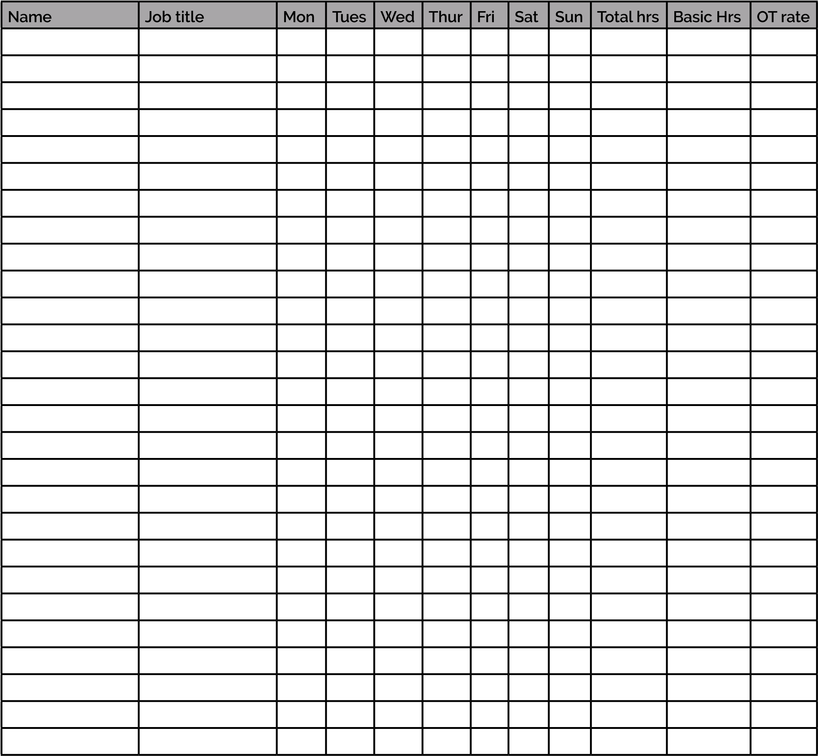

I confirm that the total hours are correct and the people named above have completed the assignment satisfactorily. Payment is to be made in accordance with Recruitment Funding Solutions Terms of Business which I accept as the basis for this transaction.

**Please email completed timesheets to diane@a1staffing.co.uk**

**To be completed and returned by 16:00 on the following SUNDAY to be processed for payment.**

|  |  |  |  |
| --- | --- | --- | --- |
| **Client Signature** |  | **Name (in caps)** |  |
| **Position** |  | **Date** | **/ /** |

www.recruitmentfundingsolutions.co.uk